Astracare- Hospital

Software requirement specification (SRS):-
Introduction
The AstraCare Hospital Management System is a web-based application developed using the MERN stack (MongoDB, Express.js, React.js, Node.js). The system is designed to digitize and streamline hospital operations such as patient registration, appointment scheduling, doctor management, diagnosis recording, prescription handling, and medical report management.
The primary goal of this system is to reduce manual paperwork, minimize operational errors, and improve communication between patients, doctors, staff, and administrators.
This SRS document defines the functional and non-functional requirements of the system and serves as a reference for developers, testers, and stakeholders during the development lifecycle.

Purpose-
AstraCare Hospital Management System is a web based application designed for AstraCare Hospital to streamline communication and coordination between hospital staff and patients. The system aims to reduce manual errors, improve data accuracy, and eliminate operational discrepancies in hospital workflows such as patient registration, appointment scheduling, and medical record management.

Scope-
The AstraCare Hospital Management System is a web based application developed to digitize and streamline the internal operations of AstraCare Hospital. The system focuses on improving efficiency, accuracy, and coordination between hospital staff and patients by replacing manual record keeping with a centralized digital platform.
The system is designed for a physical hospital environment, where patients visit the hospital in person. It supports digital management of hospital workflows, including patient registration, appointment scheduling, doctor consultation records, and medical report management.

Overall Description-

Product Perspective
The AstraCare Hospital Management System is a web-based application designed using the MERN stack (MongoDB, Express.js, React.js, Node.js). The system is initially developed and tested in a local development environment (localhost) and is intended to be deployed on cloud platforms such as Render (backend) and Vercel (frontend) for production use.
The system follows a client-server architecture where:
- Frontend (React.js) acts as the client interface
- Backend (Node.js + Express.js) handles business logic and APIs
- MongoDB serves as the database for storing hospital data
Product Functions
The system provides the following key functions:
- User authentication and role-based access control
- Patient registration and management
- Doctor management and specialization handling
- Appointment scheduling and tracking
- Medical diagnosis recording by doctors
- Prescription and treatment management
- Medical report upload and retrieval
- Staff-assisted patient registration and hospital workflow management

User Classes and Characteristics
The system supports four types of users:
- Admin: Has full control over the system including managing doctors, staff, and hospital data.
- Doctor: Responsible for patient diagnosis, prescriptions, and medical record updates.
- Patient: Can book appointments, view reports, and access personal medical history.
- Staff/Receptionist: Handles patient registration and appointment scheduling.

Operating Environment
The system operates in the following environment:
- Frontend: React.js running in modern web browsers
- Backend: Node.js runtime environment
- Database: MongoDB (local or cloud - MongoDB Atlas)
- Development Environment: Localhost (initial phase)
- Deployment Environment: Vercel (frontend) and Render (backend)

Assumptions and Dependencies
- Users have access to a web browser and internet connection (for deployed version)
- Hospital staff are trained to operate the system
- The system depends on stable backend API services
- MongoDB database must be available for data storage
- JWT-based authentication is used for secure access

External Interface Requirements-
User Interface
Hardware Interface
Software Interface
Communication Interface

System Constraints-
- Internet requirement
- MongoDB dependency
- Browser limitation
- File storage limitation

Specific Requirements-
- Functional Requirements (WHAT system does)
- Non-Functional Requirements (HOW system behaves)

Functional Requirements
Patient Management
- The system shall allow staff to register new patients.
- The system shall store patient details such as name, age, gender, contact, and medical history.
- The system shall allow viewing and updating patient information.

Doctor Management
- The system shall allow admin to add and manage doctor profiles.
- The system shall store doctor details including specialization and schedule.
- The system shall allow viewing assigned patients for each doctor.

Appointment Management
- The system shall allow patients or staff to book appointments with doctors.
- The system shall maintain appointment status (pending, confirmed, completed, cancelled).
- The system shall allow doctors to view their scheduled appointments.

Diagnosis Management
- The system shall allow doctors to record patient diagnosis after physical consultation.
- The system shall store diagnosis details such as disease, symptoms, and medical notes.
- The system shall allow updating diagnosis information if required.
Prescription Management
- The system shall allow doctors to add prescriptions for patients.
- The system shall store prescribed medicines and instructions.
- The system shall allow patients to view their prescriptions.

Report Management
- The system shall allow staff or doctors to upload medical reports.
- The system shall allow patients to view and download their reports.
- The system shall store reports linked to patient ID.

User Authentication
- The system shall provide login functionality for all users.
- The system shall support role-based access (Admin, Doctor, Patient, Staff).
- The system shall secure user sessions using JWT authentication.

Admin Management
- The system shall allow admin to manage doctors and staff.
- The system shall allow admin to view overall hospital activity.
- The system shall allow admin to manage system data.

Non-Functional Requirements
Performance Requirements
- The system shall respond to user requests within 2–3 seconds.
- The system shall handle multiple users simultaneously.

Security Requirements
- The system shall use JWT-based authentication.
- The system shall protect sensitive patient data.
- The system shall restrict access based on user roles.

Usability Requirements
- The system shall have a simple and user-friendly interface.
- The system shall be easy to use for hospital staff with basic training.

Scalability Requirements
- The system shall support future expansion of modules like billing or pharmacy.
- The system architecture shall support increased users and data load.

Portability Requirements
- The system shall run on all modern web browsers.
- The system shall be deployable on cloud platforms (Vercel, Render).

Security Requirements-
- JWT
- bcrypt
- RBAC
- protected APIs

UML USE CASE DIAGRAM-
Authentication (COMMON)
- Login
- Register

PATIENT USE CASES
- Register account
- Login
- Book appointment
- View prescriptions
- View reports

DOCTOR USE CASES
- Login
- View appointments
- View patients
- Add diagnosis
- Add prescription
- Upload report

STAFF USE CASES
- Register patient
- Schedule appointment
- Manage patient queue

ADMIN USE CASES
- Manage doctors
- Manage staff
- View system overview
- Manage departments

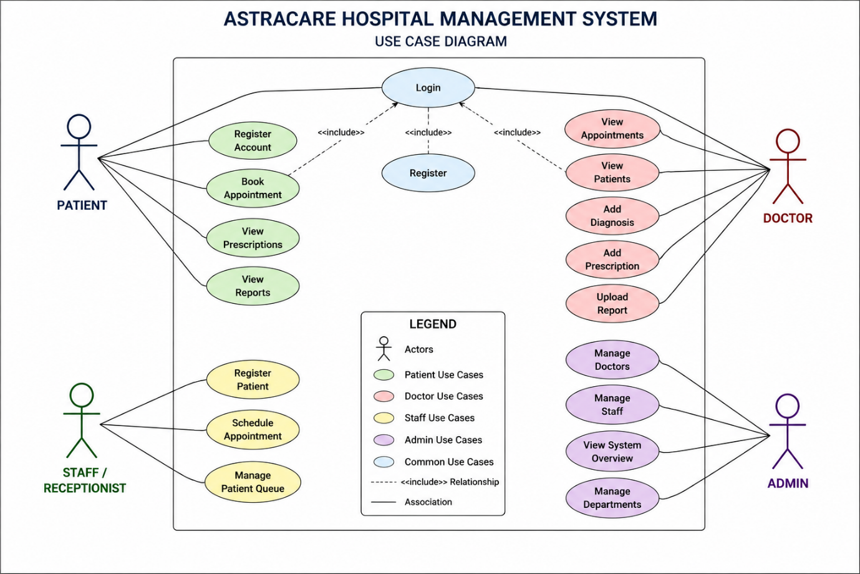

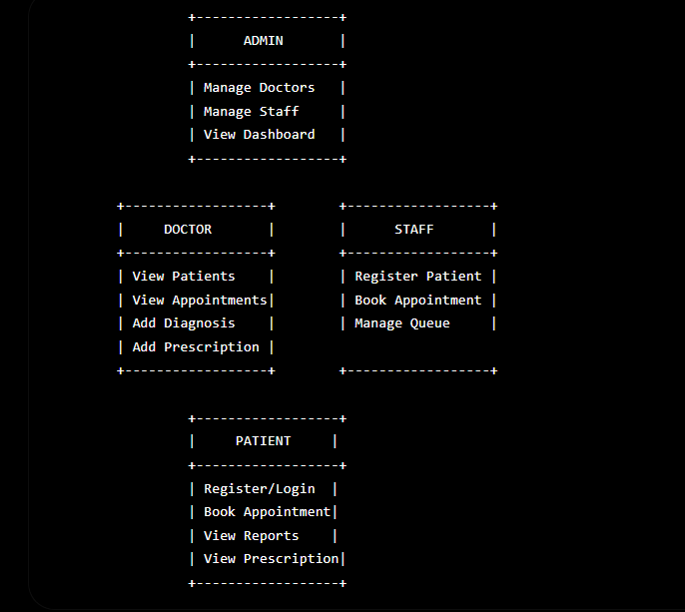

The Use Case Diagram of AstraCare Hospital Management System represents the interaction between different users and the system functionalities. The system includes four primary actors: Admin, Doctor, Patient, and Staff. Each actor interacts with specific functionalities such as patient registration, appointment scheduling, diagnosis management, and report handling.

Database-
PATIENTS COLLECTION-
const patientSchema = new mongoose.Schema({
patientId: {
type: String,
unique: true
},
name: String,
age: Number,
gender: String,
contact: String,

diseaseHistory: [
{
disease: {
type: String,
required: true
},
diagnosedOn: {
type: Date,
required: true
}
}
]
});

DOCTORS COLLECTION

{
"doctorId": "D201",
"name": "Dr. Mehta",
"specialization": "Cardiologist",
"experience": "8 years",
"contact": "9999999999"
}

Department collection-
{
"departmentId": "DEP001",
"departmentName": "Cardiology",
"headDoctorId": "D001",
"location": "Block A - Floor 2",
"contactNumber": "011-45678901",
"status": "Active"
}

{
"prescriptionId":"PR001",
"patientId":"P001",
"doctorId":"D001",
"diagnosisId":"DG001",

"medicines":[
{
"name":"Paracetamol",
"dosage":"500 mg",
"frequency":"Twice Daily",
"duration":"5 Days"
},
{
"name":"Vitamin C",
"dosage":"500 mg",
"frequency":"Once Daily",
"duration":"7 Days"
}
],

"instructions":"Take after meals"
}

APPOINTMENTS COLLECTION
{
"appointmentId": "A301",
"patientId": "P101",
"doctorId": "D201",
"date": "2026-07-10",
"time": "10:30 AM",
"status": "pending"
(status: {
type: String,
enum: [
"Waiting",
"In Consultation",
"Completed",
"Cancelled",
"No Show"
],
default: "Waiting"
} )
}

REPORTS COLLECTION
{
"reportId": "R401",
"patientId": "P101",
"reportName": "Blood Test",
"fileUrl": "/uploads/bloodtest.pdf",
"uploadedBy": "Doctor",
"uploadedAt": "2026-07-04"
}

Admin collection-
{
"adminId": "ADM001",
"name": "Vaibhav Singh",
"email": "admin@astracare.com",
"password": "$2b$10$...",
"role": "Admin"
}

RELATIONSHIPS
- Users ↔ Role-based access
- Patients ↔ Appointments
- Doctors ↔ Appointments
- Patients ↔ Reports

SIMPLE RELATION FLOW
Patient → books → Appointment → assigned to → Doctor
Doctor → creates → Diagnosis/Report → stored in Reports
Admin → manages → Users (Doctors + Staff)

Future Collections:
- Prescriptions
- Billing (optional)
- Departments

Database Design
The AstraCare Hospital Management System uses MongoDB as its database to store and manage hospital-related data. The system follows a collection-based structure where each collection represents a specific entity such as users, patients, doctors, appointments, and reports. Relationships between entities are managed using unique identifiers such as patientId and doctorId.

System Architecture –

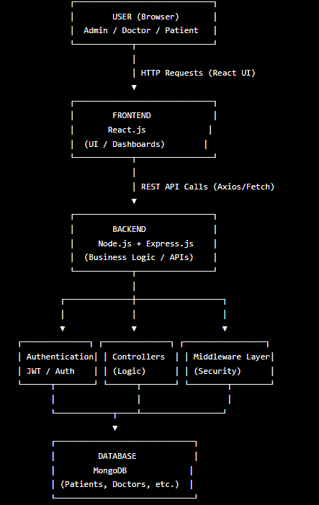

Future Enhancements-
- Billing system
- AI features
- SMS/email alerts
- Telemedicine
- Pharmacy module
- Duty chart (tabular)

- Conclusion
- The AstraCare Hospital Management System is a comprehensive web-based solution designed to modernize and streamline hospital operations using the MERN stack. The system successfully addresses key challenges in traditional hospital management such as manual record keeping, communication gaps, and operational inefficiencies.
- By digitizing core functionalities like patient registration, appointment scheduling, diagnosis management, prescription handling, and medical report processing, the system ensures improved accuracy, efficiency, and accessibility of healthcare services.
- The implementation of role-based access control (RBAC), JWT-based authentication, and secure API architecture enhances the security and reliability of sensitive medical data. The system also provides a scalable and flexible structure, allowing future enhancements such as billing systems, AI-based diagnosis support, telemedicine, and automated notifications.
- Overall, the AstraCare Hospital Management System serves as an efficient, scalable, and user-friendly platform that improves coordination between patients, doctors, staff, and administrators, thereby contributing to better healthcare service delivery.

